**TMA 02**

**DMM 6601/6602 – MANAGEMENT FOR ENGINEERS**

**Academic Year - 2024/2025**

**Bachelor of Software Engineering Honors Level 6**

**Department of Electrical and Computer Engineering**

**The Open University of Sri Lanka**

**321426009 – MBNM NASHEETH**

**CONTENTS**

Table of Contents

Q1 3

1) 3

2) 3

3) 4

4) 5

Q2 5

1) 5

2) 5

3) 6

4) 7

Q3 8

1) 8

2) 8

3) 9

4) 9

Q4 10

1) 10

2) 10

3) 11

4) 11

Q5 12

1) 12

2) 13

3) 13

4) 14

# Question 01

## a)

Inventory control balances two competing objectives, minimizing total costs such as ordering, holding, shortage costs while maintaining service quality by avoiding stockouts, meeting demand promptly. Good inventory control reduces carrying cost and waste while ensuring product availability.

Ex –

A local supermarket uses periodic inventory reviews and EOQ for non-perishable packaged goods and JIT for fresh produce. For packaged goods EOQ reduces ordering frequency and ordering costs; for fresh produce, tighter JIT reduces spoilage and ensures freshness, balancing cost and service.

## b)

|  |  |  |
| --- | --- | --- |
| **Aspect** | **Just-In-Time (JIT)** | **Economic Order Quantity (EOQ)** |
| **Objective** | Minimize or eliminate inventory by receiving materials exactly when needed for production. | Determine the optimal order quantity that minimizes total ordering and holding costs. |
| **Inventory Level** | Maintains **near-zero** inventory levels. | Maintains an **optimal fixed quantity** of inventory. |
| **Demand & Lead Time Assumptions** | Requires **highly stable demand** and **very low lead-time variability**. | Assumes **relatively stable demand** and **constant lead time**. |
| **Supplier Relationship** | Needs **strong, reliable supplier partnerships** with frequent small deliveries. | Works with **normal supplier reliability**, orders placed in bulk at calculated intervals. |
| **Cost Focus** | Reduces **storage and holding costs**, but may increase transportation or ordering frequency costs. | Balances **ordering cost** and **holding cost** to achieve minimum total cost. |
| **Risk Exposure** | **High,** vulnerable to supply disruptions or transport delays. | **Lower,** can handle moderate delays or demand changes with safety stock. |
| **Implementation Complexity** | Requires **tight process control**, coordination, and advanced scheduling. | Easier to **calculate and implement**, suitable for traditional inventory systems. |
| **Best Suited For** | Large or well-integrated firms with reliable suppliers and lean production systems. | Small and medium enterprises (SMEs) or firms with limited control over supplier timing. |

For most small and medium enterprises (SMEs) in Sri Lanka, the **EOQ system is more suitable** as it is easier to implement, cost-effective, and less dependent on highly reliable supply chains. It allows firms to balance ordering and holding costs while maintaining adequate safety stock to handle supply uncertainties common in local markets. However, **JIT may be viable** for SMEs that operate with **reliable local suppliers and short lead times**, where close coordination and consistent delivery can support lean inventory practices.

## c)

Annual demand D = 2400 units  
Ordering cost S = Rs.75 per order  
Holding cost H = Rs.12 per unit per year

EOQ = √(2DS)/H

EOQ = √ (2*2400*75)/12

EOQ = √30000

EOQ ≈ 173

No. of orders per year = 2400/173

No. of orders per year = 13.87

No. of orders per year ≈ 14

Daily demand = 2400/300 = 8

Reorder Point = 8*5 = 40 units

## d)

**Challenge 1 — Supply chain disruptions & transport instability**

1. *Context:* Seasonal road damage, fuel price spikes, strikes, customs delays, etc.
2. *Mitigation:* Maintain safety stock, diversify suppliers (local + alternate), use buffer inventory for critical items, and develop contingency transport routes/providers.

**Challenge 2 — Rising costs & currency / inflation volatility**

* *Context:* Import cost fluctuations, energy price changes increase production and logistics costs.
* *Mitigation:* Negotiate longer-term contracts, index link contracts to hedge currency/fuel, and adopt process improvements to reduce waste and energy consumption. Use supplier partnerships to lock better prices.

# Question 02

## a)

1. **Linear constraints:** Equations or inequalities that limit feasible solutions, where each constraint is linear in the decision variables (coefficients times variables + constant).
2. **Feasible solution:** A set of decision variable values that satisfies all the LP constraints (including non-negativity). It lies inside or on the boundary of the feasible region.
3. **Optimal solution:** A feasible solution that gives the best value (maximum or minimum depending on the objective) of the objective function. In LP, if an optimal solution exists, at least one occurs at a corner (extreme point) of the feasible region.

## b)

1. Variables –

* R = tons of White Rice produced per month
* F = tons of Rice Flour produced per month

1. Objective function

* Profit per ton: White Rice = Rs. 12,000, Rice Flour = Rs. 9,000
* P – Maximized Profit
* P = (12,000*R​) + (9,000*F) ​

1. Constraints

* Milling Constraint
  + (4R) + (2F) ≤ 2400
* Drying Constraint
  + (2R) + (3F) ​≤ 1200
* Non-Negativity Constraint
  + 0 ​≤ R A ND 0 ​≤ F

## c)

|  |  |  |  |
| --- | --- | --- | --- |
| Inequality | Corresponding Equation | Coordinates of x intercepts (F = 0) | Coordinates of y intercepts (R = 0) |
| (4R) + (2F) ≤ 2400 | (4R) + (2F) = 2400 | (600,0) | (0,1200) |
| (2R) + (3F) ≤ 1200 | (2R) + (3F) = 1200 | (600,0) | (0,400) |

Feasible Region (marked in Green) – (0,0), (0,400), (600,0)

P = (12,000*R​) + (9,000*F) ​

|  |  |
| --- | --- |
| Corner Points | Corresponding P (Max Profit) |
| (0,0) | 0 |
| (0,400) | 3600000 |
| (600,0) | 7200000 |

For maximum profit,

R = 600 tons, F = 0 tons

Maximum Profit = Rs. 7,200,000.00

# Question 03

## a)

The Transportation Problem schedules the shipment of goods from multiple sources to multiple destinations at minimum cost while satisfying supply and demand constraints. It helps optimize distribution costs, utilize capacities efficiently, and ensure demand satisfaction. In agriculture and manufacturing it reduces freight costs, decides sourcing-distribution patterns, and assists logistics planning.

## b)

Data Given

|  |  |  |  |  |  |
| --- | --- | --- | --- | --- | --- |
| **From\To** | **D1** | **D2** | **D3** | **D4** | **Supply** |
| **P1** | 120 | 140 | 110  240 | 150 | ~~240~~ |
| **P2** | 100  180 | 130  120 | 160  60 | 120 | ~~360~~  ~~60~~  ~~180~~ |
| **P3** | 140 | 120  ~~120~~  100 | 150  ~~60~~ | 110  200 | ~~300~~  ~~100~~ |
| **Demand** | ~~180~~ | ~~220~~ | ~~300~~ | ~~200~~ |  |

## c)

no. of allocations – 6

m + n -1 = 3+4-1 = 6

Therefore, this solution is in degenerate status.

Minimum Total Cost = 110*240 + 100*180 + 130*120 + 160*60 + 120*100 + 110*200

Minimum Total Cost = 26400 + 18000 + 15600 + 9600 + 12000 + 22000

Minimum Total Cost = Rs. 103,600.00

## d)

1. Fuel Price Fluctuations:
   * Frequent and unpredictable changes in fuel prices directly affect transportation costs. Since the traditional Transportation Model assumes fixed costs, sudden price hikes make the calculated optimal routes and allocations unrealistic or outdated.
2. Poor Road Infrastructure and Traffic Conditions:

* Many rural and regional routes in Sri Lanka have poor road conditions, congestion, or limited accessibility during certain seasons. These factors increase travel time and maintenance costs, which are not reflected in the basic model’s static cost assumptions.

Suggestion: Use a Dynamic Transportation Model with Variable Costs:

Companies can modify the standard model to include variable or scenario-based cost parameters that change with real-time data—such as fuel prices, road conditions, or delivery times. By integrating these updates (e.g., through periodic recalculation or software-based optimization), the model becomes more responsive to actual operating conditions.

# Question 04

## a)

Network scheduling is used to plan, organize, and control the sequence of project activities to ensure that the project is completed on time and within resources. It helps project managers visualize the entire project, identify dependencies between tasks, estimate the total project duration, and determine which activities are most critical to meeting deadlines.

Key Terms

I. Work Breakdown Structure (WBS)

This is a hierarchical breakdown of the project into smaller, manageable tasks or work packages. It helps clearly define what needs to be done before scheduling begins.

WBS provides the foundation by breaking the project into clear tasks.

II. Critical Path Method (CPM)

CPM is a technique used to identify the longest path of dependent activities and the minimum project duration. Activities on this path have zero slack, meaning any delay in them will delay the whole project.

CPM helps focus management attention on critical activities that directly affect the schedule.

III. Program Evaluation and Review Technique (PERT):

PERT is used when activity times are uncertain. It uses three-time estimates (optimistic, most likely, and pessimistic) to calculate expected durations and analyze the probability of completing the project on time.

PERT adds flexibility by handling uncertainty in task durations.

## b)

|  |  |
| --- | --- |
| C:\Users\hp\AppData\Local\Microsoft\Windows\INetCache\Content.MSO\ABD8B23A.tmp | ES – Early Start  EF – Early Finish  LS – Late Start  LF – Late Finish  I – Interval  F - Float |

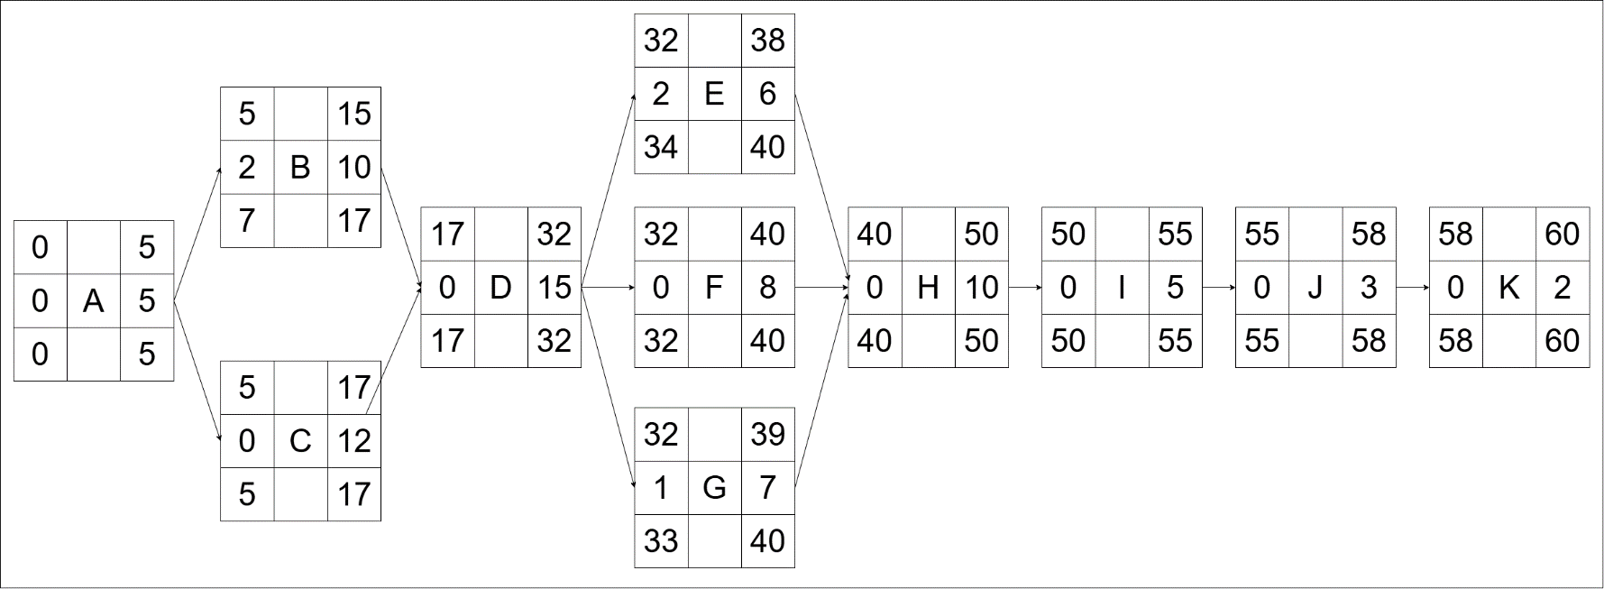

Project Duration = 60 days

Critical Path – A 🡪 C 🡪 D 🡪 F 🡪 H 🡪 I 🡪 J 🡪 K

Activities that can be delayed – B (2 Days), E (2 Days), G (1 Day)